Spills and Exposure Procedures

All spills or breaks involving Recombinant DNA or Synthetic Nucleic Acid Molecules and hazardous biological materials should be cleaned up using appropriate biosafety procedures, described below. If there is any doubt about what to do, call the PI (Telephone #), or the Biosafety Officer 1-6590, or the University’s internal emergency number: 5-2677.

The following items should be included in a biological spill kit:
- Disinfectant – Prepare a fresh 1:10 bleach solution. In other words, a pre-measured amount of bleach in a spray bottle is placed in the spill kit, but the cold water required to dilute the bleach is not added until right before use. Otherwise, use an EPA-registered disinfectant (effective against HIV and HBV) following manufacturer’s instructions. Examples are Cavicide, Cidex OPA and Clidox-S. Note the date of manufacture and/or expiration.
- Absorbent material (paper towel, absorbent powder)
- Personal protective equipment (e.g., disposable gloves (2 pairs), eye protection, face shield or surgical mask, lab coat, shoe covers). It is necessary to review the PPE in the spill kit on a regular basis to verify quality. Gloves can degrade due to exposure to UV or fluorescent lighting, temperature extremes, and the effects of time. At the first sign of degradation (e.g., discoloration, brittleness, stickiness, tearing), replace the gloves in the spill kit with new ones. Likewise, the strap on splash goggles can undergo similar degradative processes.
- Mechanical tools (forceps or tongs, broom and dustpan) – Dispose of biohazardous waste after spill response. Purchase inexpensive plastic tools for this purpose.
- Waste container (biohazard bags) – By assembling all of the spill materials in a bucket or other leak-proof and puncture-proof container, you will have a secondary container readily available for proper containment of your biohazard bag.

- Spills inside of a Biosafety Cabinet
  - Stop work.
  - If you are splashed by the material, change PPE. Always change gloves.
  - Keep the biosafety cabinet running.
  - Contain the spill by covering with paper towels (to avoid splashes or aerosols).
  - Prepare the disinfectant.
  - Saturate spill with XXXXXXX (fill in the appropriate decontaminant). Let sit for 20 minute exposure time.
    - For large spills (greater than 10ml) use undiluted bleach or disinfectant.
    - In the event of a spill into the drip pan/catch basin, add an equal volume of disinfectant and wait for 20 minutes to clean up the disinfected material.
    - Note: due to its evaporative nature alcohol is not recommended as the primary disinfectant but can be used to remove bleach/disinfectant residue.
    - If working with human blood or OPIM (such as human cell line) spills must be disinfected with an EPA-approved disinfectant (alcohol is not on the approved lists).
  - Wipe up spill, disposing of towels in biohazard bag.
  - Spray spill area with XXXXXXX (fill in the appropriate decontaminant). Allow to air dry.
  - Disinfect all other materials used in the biosafety cabinet by disinfecting the surface with XXXXXXX (fill in the appropriate decontaminant) with a 20 minute contact time. Do not attempt to disinfect contaminated cardboard or other paper items that absorb liquid: contaminated items should be disposed of.
  - If bleach or other corrosive disinfectant used, wipe spill area and disinfected equipment with alcohol or water.
  - Place all towels or absorbent materials into a designated container for biohazardous waste.
  - Remove PPE, discard disposable PPE as biohazardous waste and wash hands.
  - Run the biosafety cabinet for 10 minutes to purge the air before re-starting work.

- Spills outside of a Biosafety Cabinet
  - Stop work.
  - If you are splashed by the material, dispose of PPE and wash hands.
  - Ensure that any other people in the vicinity are notified that a spill has occurred and that the room should be evacuated. Post a “Do Not Enter” notice on the door. Notify the PI or lab supervisor.
  - If you need assistance with the spill clean-up, call OEHS (1-6590).
  - Wait 60 minutes before re-entering the room to allow aerosols to settle.
  - Assemble Spill cleanup materials and don PPE, including lab coat, eye protection and face shield or mask, 2 pair of gloves, shoe covers. If the lab coat does not have cuffed sleeves, disposable sleeve covers should be worn.
  - Contain the spill by covering with paper towels (to avoid splashes or aerosols)
  - Saturate spill with XXXXXXX (fill in the appropriate decontaminant). Let sit for 20 minute exposure time.
    - For large spills (greater than 10ml) use undiluted bleach or disinfectant.
    - Wipe areas around the spill that may have splatter and any reusable equipment with XXXXXXX (fill in the appropriate decontaminant).
    - If working with human blood or OPIM (such as human cell line) spills must be disinfected with an EPA-approved disinfectant (alcohol is not on the approved lists).
  - Wipe up spill, disposing of towels in biohazard bag: if sharps may be present use tongs or a brush and pan and dispose in biohazard sharps container.
    - Work concentrically to clean up the absorbent material. Always work from the outer edge of the spill toward the center.
  - Spray spill area with XXXXXXX (fill in the appropriate decontaminant). Allow to air dry.
  - If bleach or other corrosive disinfectant used, wipe spill area and disinfected equipment with alcohol or water.
  - Remove PPE, discard disposable PPE as biohazardous waste and wash hands.
  - Remove the “Do Not Enter” sign and inform others that it is safe to re-enter the room.
  - Once the spill has been contained, complete the “SPILLS OR EXPOSURE EVENT REPORTING PROCEDURE” form (below) and have the PI send to OEHS.

- Spills Inside of a Centrifuge Contained Within a Closed Cup, Bucket, or Rotor
  - Put on lab coat, gloves, and proper eye protection prior to opening centrifuge. Open carefully to assess the damage.
  - Prepare the disinfectant: consult the instructions of the centrifuge rotor to identify suitable disinfectants.
  - If the spill is contained within a closed cup, bucket, or rotor, spray the exterior with disinfectant and allow at least 20 minutes of contact time. Remove the carrier to the nearest biosafety cabinet (BSC).
    - Note, if possible, avoid using bleach on centrifuge rotors and buckets to avoid damaging the equipment. If bleach is used, ensure all surfaces are wiped down with soap and water after disinfection. Alternatively, use an EPA-registered disinfectant, such as Cidex or Cavicide.
  - Gather supplies needed, such as a sharps container for broken glass and bins filled with disinfectant and place into the BSC.
  - Open the centrifuge rotor or bucket inside of the BSC. Use a mechanical device (forceps, tongs, etc.) to remove broken glass and place directly into sharps container. Carefully remove any unbroken tubes and place into a bin filled with XXXXXXX (fill in the appropriate decontaminant) for at least 20 minutes. Wipe carrier/bucket with disinfectant.
  - After disinfection, carrier, bucket, or rotor must be washed with a mild soap and water.
  - Spray the interior of the centrifuge chamber with XXXXXXX (fill in the appropriate decontaminant), let sit for at least 20 minutes and then wipe down with soap and water.
  - Dispose of all clean-up materials (except sharps) in an appropriate biohazardous waste container. Dispose of sharps in a biohazard sharps container.
  - Remove PPE, discard disposable PPE as biohazardous waste and wash hands.

If you are concerned that the spill is not contained within the rotor or bucket:
    - Ensure that any other people in the vicinity are notified that a spill has occurred and the room should be evacuated. Post a “Do Not Enter” notice on the door. Notify the PI or lab supervisor.
    - If you need assistance with the spill clean-up, call OEHS (801-581-6590)
    - Wait 60 minutes before re-entering the room to allow aerosols to settle.
    - Proceed with clean up as described above.

Note: Many centrifuge rotors can be disinfected by autoclaving. Check the manufacturer’s instructions.

- Exposure to skin or clothing
  - Stop work.
  - Take off contaminated clothing and wash affected area thoroughly with soap and water, but not so hard the skin is abraded.
  - If necessary, exit lab area and immediately take a shower. Wash thoroughly with soap and water, but not so hard the skin is abraded.
  - Notify the lab supervisor or PI.
  - If exposed to BSL-2/RG2 (or above) agent, notify the Biosafety Officer and Proceed directly to RedMed Clinic, Redwood Occupational Medicine Clinic, or the University of Utah Hospital Emergency Room (if after 8pm).

- Penetrating wound
  - Stop Work.
  - Wash immediately with soap and water.
  - Notify lab supervisor or PI, who must notify the Biosafety Officer.
  - Proceed directly to RedMed Clinic, Redwood Occupational Medicine Clinic, or the University of Utah Hospital Emergency Room (if after 8pm).

- Eyes, or mucous membrane exposure
  - Stop work.
  - Immediately flush eyes or mucous membrane with water for 10-15 minutes.
  - Notify lab supervisor or PI, who must notify the Biosafety Officer.
  - Proceed directly to RedMed Clinic, Redwood Occupational Medicine Clinic, or the University of Utah Hospital emergency Room (if after 8pm).

- Emergency Spills: Environmental Risk
  - Stop work.
  - Ensure that any other people in the vicinity are notified that a spill has occurred and that the room should be evacuated. Post a “Do Not Enter” notice on the door. Notify the PI or lab supervisor.
  - Call OEHS (801-581-6590). Provide information on the nature of the material spilled.
  - Take appropriate precautions to limit exposure or spread of spill to other areas.

NOTE: Spill Procedures must be clearly posted in the BSL-2 suite

Actions in the Event of an Exposure

Definition of Exposure
- Direct skin, eye or mucosal membrane exposure to the agent or materials potentially containing the agent, such as tissue culture media or cells, bodily fluids from infected animals.
- Parenteral inoculation by a syringe needle or other contaminated sharp (needlestick),
- Ingestion of liquid suspension of an infected material or by contaminated hand to mouth exposure, or
- Inhalation of infectious aerosols.

Information for Lab Personnel
- Remove exposed PPE taking care to avoid contact of unexposed areas to infectious agents on the PPE.

- Inform others in area about any biohazardous materials out of containment to prevent further exposure. If possible, contain with absorbent pads, decontaminate with bleach, and/or seal off the site. ALL exposed individuals should leave the area.

- Immediately wash affected areas with soap and water, or if exposure to eyes or mucous membranes occurred, immediately flush affected area with water for 10-15 minutes. See exposure procedures for further information.

- After washing, Notify lab supervisor or Principal Investigator of the exposure (PI’s 24-hour Emergency Contact Number: (XXX) XXX-XXXX).

- Go immediately to the RedMed Employee Health Clinic at the University Union Building or the Occupational Medical Clinic at the Redwood Health Center for medical evaluation and follow-up; contact information is below. After 5pm you will be seen by an Urgent Care Physician. After 8pm, or if the injury is serious/life threatening, go to the University of Utah Hospital Emergency Department or call an ambulance (911).

- Ensure that the physician is aware of all materials that were being used at the time of exposure (e.g., virus, bacteria, human tissue, animal tissue, other potentially infected material). Take a completed copy of the risk assessment and treatment options of this SOP with you!

- Follow up with the physician at Occupational Medicine, as requested.
RedMed Employee Health Clinic
200 Central Campus Dr.
Salt Lake City, UT 84112
Phone: (801) 213-3303
Hours: M-TH: 8:00AM – 5:00PM, Friday: 9:00AM – 3:30PM
Closed from 1:30 to 2:00PM

Redwood Health Center
Occupational Medicine Clinic
1525 West 2100 South
Salt Lake City, UT 84119
Phone: (801) 213-9777
Hours: M-F 8:00AM – 5:00PM

After Hours
Redwood Urgent Care
1525 West 2100 South
Salt Lake City, UT 84119
M-F 5:00PM – 8:00PM
Sat.-Sun.: 9:00AM – 8:00PM
(801) 213-9700

After 8 PM
Emergency Department at University Hospital
(main floor northeast side of the hospital)
50 N. Medical Drive
Salt Lake City, UT 84132
(801) 581-2292

- Post exposure prophylaxis must be initiated as soon as possible after exposure.

- Inform the Healthcare Provider of any medical conditions, such as pregnancy or immunosuppression, or drug treatment that you currently have or take. The Healthcare Provider must have this information to evaluate and develop a proper post treatment evaluation.

- Upon returning to work, fill out the Employers First Report of Injury E1 Form. This form can be downloaded from the human resources website under “Forms” (https://www.hr.utah.edu/forms/index.php).

- After medical care, ensure that the incident is immediately reported to the Biosafety Officer (801-581-6590).

- Have the PI/Supervisor complete a “SPILL OR EXPOSURE EVENT REPORT,” using the template below, and submit to the Biosafety Officer (801-581-6590).

Maps of Occupational Medicine Clinics
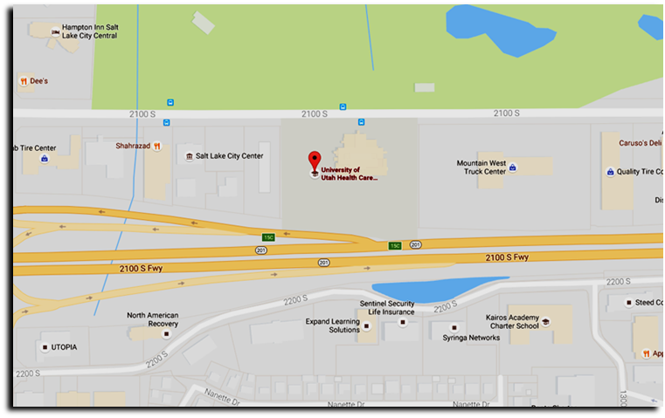
UNIVERSITY OF UTAH REDWOOD HEALTH CENTER OCCUPATIONAL MEDICINE
1525 W. 2100 S. Salt Lake City UT, 84119

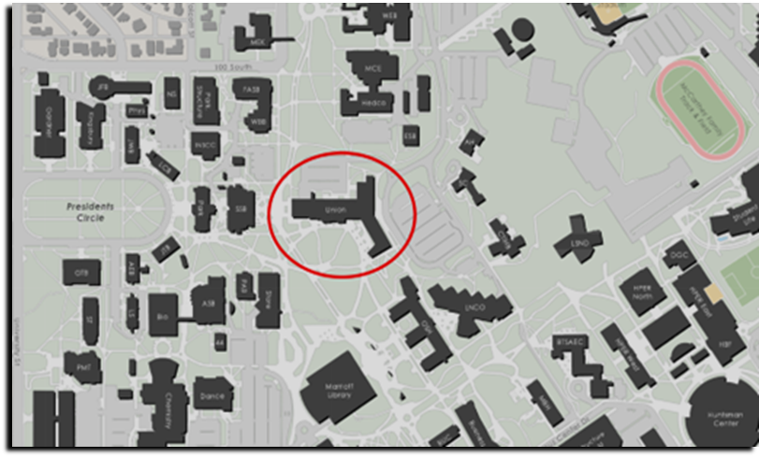
REDMED EMPLOYEE HEALTH CLINIC
200 Central Campus Dr. Salt Lake City, UT 84112

SPILLS OR EXPOSURE EVENT REPORTING PROCEDURE

Any significant problems, violations of the NIH Guidelines, or any significant research-related accidents and illnesses must be reported to the IBC so that a report can be sent to the NIH Office of Science Policy (OSP) within 30 days. Certain types of accidents must be reported on a more expedited basis. Spills or accidents in BL2 laboratories resulting in an overt exposure must be immediately reported to the IBC and OSP. Spills or accidents occurring in high containment (BL3 or BL4) laboratories resulting in an overt or potential exposure must be immediately reported to OSP.

Any spill or accident involving recombinant or synthetic DNA research of the nature described in the previous paragraph or that otherwise leads to personal injury or illness or to a breach of containment must be reported to the IBC and OSP. These kinds of events might include skin punctures with needles containing recombinant or synthetic DNA, the escape or improper disposition of a transgenic animal, or spills of high-risk recombinant materials occurring outside of a biosafety cabinet. Failure to adhere to the containment and biosafety practices articulated in the NIH Guidelines must also be reported to IBC and OSP.

In addition, exposure to Infectious Agents or Other Potentially Infected Material should be reported to the IBC.

Minor spills of low-risk agents not involving a breach of containment that were properly cleaned and decontaminated generally do not need to be reported. If the investigator, or other institutional staff are uncertain whether the nature or severity of the incident warrants reporting, contact the Biosafety Officer who can assist in making this determination, with guidance from OSP, if necessary.

Please complete the form below and submit to the Biosafety Officer (801-581-6590).

